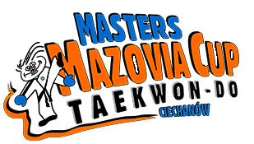

MASTERS MAZOVIA CUP
24th October 2009

General Classification

Place | Club | Medals
Place | Club | Gold | Silver | Bronze
1 | LKS „Matsogi” Ciechanów | 5 | 1 | 1
2 | Rosja | 3 | 1
3 | KST Kolbudy | 1 | 2
4 | WAT Wrocław | 1 | 1 | 7
5 | SKS Start Olsztyn | 1 |  | 1
6 | KST „Taekwon” Warszawa | 1
7 | LSKT Lublin |  | 3
8 | LKS „Lotos” Jabłonna |  | 2
9 | Ukraina |  | 1
9 | MKS”Lewart” Lubartów |  | 1
10 | LKS „Victoria” Działoszyn |  |  | 1
10 | WSKT Wrocław |  |  | 1
10 | Słowacja |  |  | 1
13 | MKS RAT Radzyń Podlaski | - | - | -

